
COMPUTER SCIENCE PRACTICAL FILE
BATCH 2024-25

NAME : Sannidhya Biswas
CLASS/ SECTION : XII-B
UNIQUE ID :
INDEX NUMBER :



CERTIFICATE OF AUTHENTICITY

This is to certify that _____________________________, UID No.

___________________ is a candidate of ISC 2025 of Delhi Public School Newtown, has carried out the Computer Science practical work under the supervision of Ms. Madhurima Acharya. This project is truly authentic and not copied from any source.

Madhurima Acharya
(HOD Computer Science)

Sonali Sen
(Principal)

INDEX:

Q1)A class Collection contains an array of 100 integers. Using the following class description, create an array with common elements from two integer arrays. Some of the members of the class are given below:

Class name : Collection Data members :
ar[] : integer array of 100 elements len : length of the array
Member methods :
Collection() : default constructor
Collection(int ) : parameterized constructor to assign the length of the array void input() : reads array elements
Collection common(Collection): return the Collection containing the common Elements of current Collection and the collection object passed as parameter. void display() : displays the array Collection elements
Write the main() method to generate the necessary output.
Algorithm:
STEP 1: START
STEP 2: INITIALIZE array ar[], len STEP 3: Accept the length of array(len)
STEP 4: Accept values in ar[] from the user
STEP 5: Make 2 different objects and do STEP 3 & STEP 4
STEP 6: Compare the elements of the arrays of the 2 objects.(assume A & B object)
STEP 7: The common elements of A & B are stored in the array of another different object.(assume C object) STEP 8: The number of common elements of A & B(Length of C object) are stored in another variable “count”.
STEP 9: Printing the array of C object along with its length STEP 10: STOP

Source Code:
import java.util.Scanner; public class Collection
{
int ar[]; int len;
Collection() //Constructor
{
ar = new int[0]; len = 0;
}
Collection(int l) //Parameterized Constructor
{
ar = new int[l]; len = l;
}
void input()
{
Scanner sc = new Scanner(System.in); System.out.println("Enter " + len + " integer elements:"); for (int i = 0; i < len; i++)
{
ar[i] = sc.nextInt();
}
}
Collection common1(Collection c) //Function checks for any common value and find the number of common value
{
Collection common = new Collection(len); int count = 0;
for (int i = 0; i < len; i++)
{
for (int j = 0; j < c.len; j++)
{
if (ar[i] == c.ar[j])//Finds the common value
{
common.ar[count] = ar[i]; count++;//Number of common value break;
}
}
}
common.len = count; return common;
}
void display()//Display function
{
System.out.print("Collection: ");

for (int i = 0; i < len; i++)
{
if (ar[i] != 0)
{
System.out.print(ar[i] + " ");
}
}
System.out.println();
}
public static void main(String[] args)
{
Collection c1 = new Collection(100);//1st array c1.input();//1st array value
Collection c2 = new Collection(100);//2nd array c2.input();//2nd array value
Collection common2 = c1.common1(c2);//Adjusting the number of common value in 2 array common2.display();//Displaying the common value array
}
}

VDT:

Variable | Datatype | Function
ar[] | int | Stores the integer value
len | int | Stores the length of array
count | int | Stores the length of array of common elements
i | int | Stores the integer value used in loop
j | int | Stores the integer value used in loop

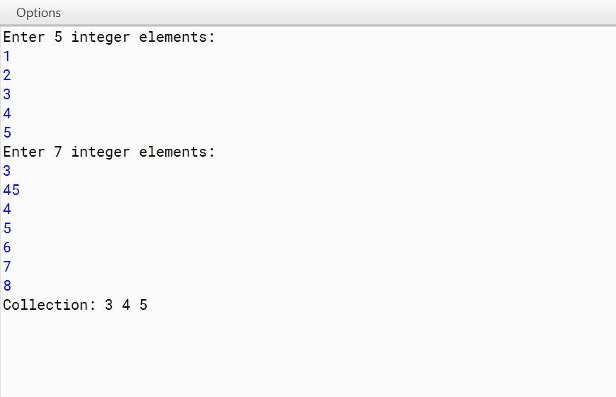
Output:
*NOTE: For convenience used 5, 7 length of array and not 100 length of array.

Q2)A Transpose of an array is obtained by interchanging the elements of the rows and columns. A class Transarray contains a two dimensional integer array of order [m x n]. The maximum value possible for both `m’ and `n’ is
20. Design a class Transarray to find the transpose of a given matrix. The details of the members of the class are given below

Class name : Transarray
Data members/instance variables :
arr[][] : stores the matrix elements
M : integer to store the number of rows
N : integer to store the number of columns Member functions :
Transarray() : default constructor
Transarray(int mm, int nn) : to initialize the size of the matrix, m=mm, n=nn void fillarray() : to enter the elements of the matrix
void transpose(Transarray A) : to find the transpose of a given matrix void disparrary() : displays the array in a matrix form
Specify the class Transarray giving the details of the constructors, void fillarray(),void transpose(Transarray) and void disparray(). You need not write the main function.

Algorithm:
STEP 1: START
STEP 2: INITIALIZE array arr[][], M, N
STEP 3: Accept values of M(as number of rows), N(as number of columns), values of arr[][] STEP 4: Check whether the value of M, N are less than 20 if more than 20 then stop the program STEP 5: INITIALIZE array transposearray[][]
STEP 6: Set the number of rows & columns of transposearray[][] as N & M respectively
STEP 7: equate the value of transposearray[N][M] to arr[M][N] and run loop over this expression to change dimensions in order to find its transpose
STEP 8: Use “\t” to print the elements in tabular form STEP 9: Print the elements of transposearray[][] STEP 10: STOP

Source Code:
import java.util.Scanner; class Transarray
{
private int[][] arr; private int M; private int N; public Transarray()
{
// Default constructor M = 0;
N = 0;
arr = null;
}
public Transarray(int mm, int nn)
{
M = mm; N = nn;
if(M > 20 || N > 20)
{
System.exit(0);
}
else
{
arr = new int[M][N];
}
}
public void fillarray()
{
// Code to enter the elements of the matrix
// Assuming user input or any other desired method to fill the array Scanner scanner = new Scanner(System.in); System.out.println("Enter the elements of the matrix:");
for (int i = 0; i < M; i++)
{
for (int j = 0; j < N; j++)
{
System.out.print(" Enter the element of " + "["+j+"]"+"["+i+"] :"); arr[i][j] = scanner.nextInt();
System.out.println();
}
}
}
public void transpose()
{
// Code to find the transpose of the given matrix int[][] transposedArray = new int[N][M];
for (int i = 0; i < N; i++)

{
for (int j = 0; j < M; j++)
{
transposedArray[i][j] = arr[j][i];
}
}
arr = transposedArray; int temp = M;
M = N;
N = temp;
}
public void disparray()
{
// Code to display the array in matrix form System.out.println("Matrix:");
for (int i = 0; i < M; i++)
{
for (int j = 0; j < N; j++)
{
System.out.print(arr[i][j] + " ");
}
System.out.println();
}
}
}

VDT:

Variable | Datatype | Function
arr[][] | int | Stores the integer value
transposedArray[][] | int | Stores the integer value
M | int | Stores the number of rows
N | int | Stores the number of columns
i | int | Stores the integer value used in loop
j | int | Stores the integer value used in loop
mm | int | Stores the number of rows
nn | int | Stores the number of columns

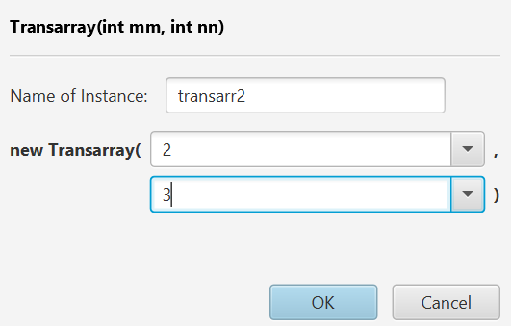
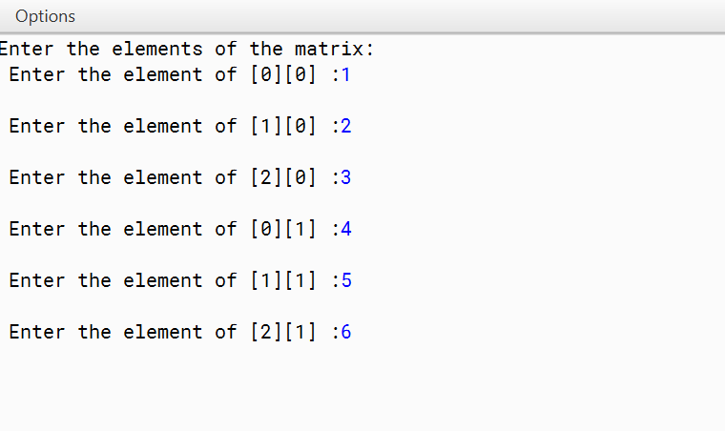
Output:

Before Transpose | After Transpose
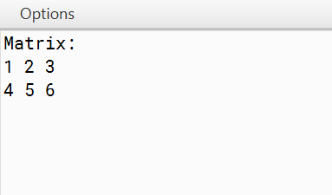 | 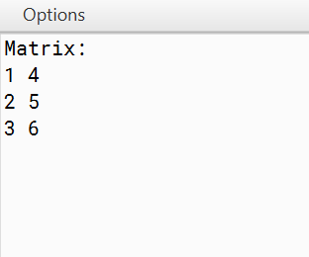

Q3)A class Array is declared as follows:
Class name : Array Data members :
ar[] : integer array of size 100 n : size of the array
num : integer variable Member methods :
Array() : a constructor to store 0 at each location of ar[] and to n. void getArray() : to input n integers in array
int process(Array B, int k): to assign k to num and return the frequency of num from the array ar[] from the array object B.
Array merge(Array a) : merge the current array with the parameterized array.
void display() : to print the array elements in such a way that only 4 elements of the array should be printed in one line with two spaces in between the numbers.
Write main() method and call the above methods to generate the output.

Algorithm:
STEP 1: START
STEP 2: INITIALIZE n, num, ar[]
STEP 3: Accept the values of n(size of array, <= 100), num, array ar[]
STEP 4: find the elements in a loop equal to num and calculate their frequency in the array
STEP 5: Create an object(assume A) and add its size with the current object(assume B) to find the merged array’s size
STEP 6: Use one loop to equate the value of array of B to the Merged array STEP 7: Use another loop to equate the value of array of A to the Merged array
STEP 8: If the number of elements to be printed in a row is 4 then we need to change the row to the next row when the elements of merged array exceeds multiples of 4 periodically
STEP 9: Print the elements of merged array STEP 10: STOP

Source Code:
import java.util.Scanner; class Array
{
private int[] ar; private int n; private int num;
public Array() //a constructor to store 0 at each location of ar[] and to n
{
ar = new int[100];
for (int i = 0; i < 100; i++)
{
ar[i] = 0;
}
n = 0;
}
public void getArray()//to input n integers in array
{
Scanner scanner = new Scanner(System.in); System.out.print("Enter the size of the array: "); n = scanner.nextInt();
System.out.println("Enter " + n + " integers:"); for (int i = 0; i < n; i++)
{
ar[i] = scanner.nextInt();
}
}
public int process(Array B, int k) //to assign k to num and return the frequency of num from the array ar[] from the array object B.
{
num = k;
int frequency = 0;
for (int i = 0; i < n; i++)
{
if (ar[i] == num)
{
frequency++;//Frequency of the number
}
}
return frequency;
}
public Array merge(Array a)//merge the current array with the parameterized array
{
Array mergedArray = new Array(); mergedArray.n = n + a.n;
for (int i = 0; i < n; i++) // Merging loop
{
mergedArray.ar[i] = ar[i];

}
for (int i = 0; i < a.n; i++)
{
mergedArray.ar[n + i] = a.ar[i];
}
return mergedArray;
}
public void display() //to print the array elements in such a way that only 4 elements of array should be printed in one line with two spaces in
between the numbers.
{
System.out.println("Array Elements:"); for (int i = 0; i < n; i++) //Display loop
{
System.out.print(ar[i] + " "); if ((i + 1) % 4 == 0)
{
System.out.println();
}
}
System.out.println();
}
public static void main(String[] args) //main method
{
Array array1 = new Array(); Array array2 = new Array(); array1.getArray();
System.out.print("Enter a number to process: "); Scanner scanner = new Scanner(System.in);
int number = scanner.nextInt();
int frequency = array1.process(array2, number); System.out.println("Frequency of " + number + ": " + frequency); array2.getArray();
Array mergedArray = array1.merge(array2); array1.display();
array2.display(); mergedArray.display();
}
}

VDT:

Variable | Datatype | Function
ar[] | int | Stores the integer value
n | int | Stores the length of array
num | int | Stores the number to be searched
i | int | Stores the integer value used in loop
number | int | Stores the number to be searched
k | int | Stores the number to be searched
frequency | int | Stores the frequency of the number

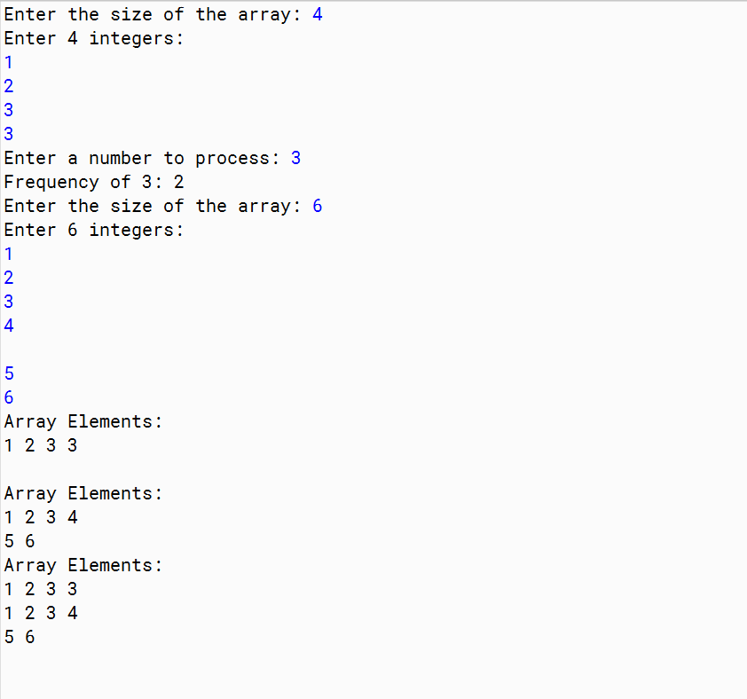
Output:

Q4)A class Time is declared as follows:
Class name : Time Data members :
hrs, min : integers to store hour and minute Methods :
Time() : default constructor to assign 0 to data members void getTime(int h, int m): assigns hours and minutes void printTime() : prints time in hh:mm format
Time sumTime(Time t1, Time t2): adds two time t1 with t2 and return their sum.
Implement the above class and write main() method and call the above methods to generate the output.

Algorithm:
STEP 1: START
STEP 2: INITIALIZE h1, h2, m1, m2
STEP 3: Associate h1, m1 with object time1 STEP 4: Associate h2, m2 with object time2 STEP 5: Print time1, time2
STEP 6: Add the 2 times in object time1, time2 STEP 7: Add h1 + h2 (Total hours)
STEP 8: Add m1 + m2 (Total minutes)
STEP 9: If total minutes exceed 60 minutes then divide it by 60, add the quotient with total hours and adjust total minutes to be remainder
STEP 10: Print the total time in time format STEP 11: STOP

Source Code:
class Time
{
private int hrs; private int min; public Time()
{
hrs = 0;
min = 0;
}
public void getTime(int h, int m)
{
hrs = h; min = m;
}
public void printTime()
{
System.out.printf("%02d:%02d\n", hrs, min);//Printing in time format
}
public static Time sumTime(Time t1, Time t2)
{
Time sum = new Time(); sum.hrs = t1.hrs + t2.hrs; sum.min = t1.min + t2.min; if (sum.min >= 60)
{
sum.hrs += sum.min / 60; sum.min %= 60;
}
return sum;
}
public static void main(String[] args)
{
Scanner sc = new Scanner(System.in);
// Taking Input for Time 1 and Time 2 System.out.println("Time 1 hour:"); int h1 = sc.nextInt(); System.out.println("Time 1 minutes:"); int m1 = sc.nextInt(); System.out.println("Time 2 hour:"); int h2 = sc.nextInt(); System.out.println("Time 2 minutes:"); int m2 = sc.nextInt();
// Create two Time objects Time time1 = new Time(); Time time2 = new Time();
// Set the time values time1.getTime(h1, m1);

time2.getTime(h2, m2);
// Print the individual times System.out.println("Time 1:"); time1.printTime(); System.out.println("Time 2:"); time2.printTime();
// Sum the two times and print the result
Time sumTime = Time.sumTime(time1, time2); System.out.println("Sum of Time 1 and Time 2:"); sumTime.printTime();
}
}

VDT:

Variable | Datatype | Function
hrs | int | Stores the hour value
min | int | Stores the minute value
h1 | int | Stores the hour value
h2 | int | Stores the minute value
m1 | int | Stores the hour value
m2 | int | Stores the minute value

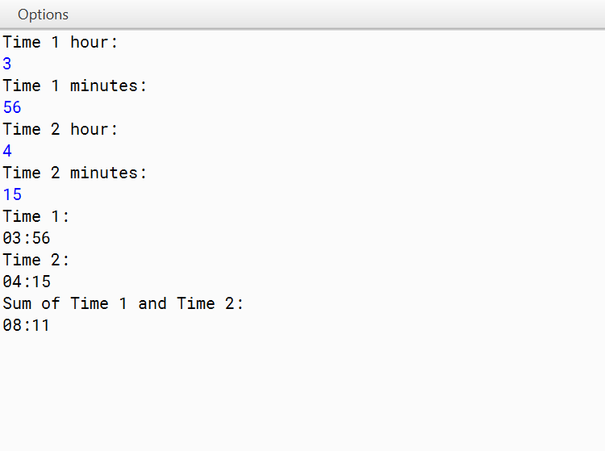
Output:

Q5)Class Matrix contains a two dimensional integer array of order [ m x n ]. The maximum value possible for both m and n is 25. Design a class Matrix to find the difference of the two matrices. The details of the members of the class are given below:
Class name : Matrix Data members
arr[][] : stores the matrix element
m : integer to store the number of rows
n : integer to store the number of columns Member functions:
Matrix(int mm, int nn) : to initialize the size of the matrix m=mm and n=nn void fillarray() : to enter the elements of the matrix
Matrix SubMat(Matrix A) : subtract the current object from the matrix of the parameterized object and return the resulting object.
void display() : display the matrix elements.
Specify the class Matrix giving details of the constructor(int,int), void fillarray(),Matrix SubMat(Matrix) and void display(). Define the main() function to create an object and call the functions accordingly to enable the task.

Algorithm:
STEP 1: START
STEP 2: INITIALIZE array arr[][], M, N
STEP 3: Take the input of arr[][], M(no of rows), N(no of columns) from the user STEP 4: Create an object (assume A)
STEP 5: Making sure the array of object A has same dimensions
STEP 6: Construct a loop such a way that it finds the difference between the elements of the array of existing object(assume B) and object A
STEP 7: Create an object(assume result)
STEP 8: Making sure the array of object result has same dimensions
STEP 9: Equate the elements of the array of result object to that of the difference of between the elements of the array of object B and object A
STEP 10: Print the array of result object in tabular form STEP 11: STOP

Source Code:
import java.util.Scanner; class Matrix
{
private int[][] arr;//stores the matrix element private int m;//integer to store the number of rows
private int n;//integer to store the number of coloumns
public Matrix(int mm, int nn)//to initialize the size of the matrix m=mm and n=nn
{
m = mm; n = nn;
arr = new int[m][n];
}
public void fillArray() //to enter the elements of the matrix
{
Scanner scanner = new Scanner(System.in); for (int i = 0; i < m; i++)
{
for (int j = 0; j < n; j++)
{
arr[i][j] = scanner.nextInt();
}
}
}
public Matrix subMat(Matrix A)//subtract the current object from the matrix of the parameterized object and return the resulting object.
{
Matrix result = new Matrix(m, n); for (int i = 0; i < m; i++)
{
for (int j = 0; j < n; j++)
{
result.arr[i][j] = arr[i][j] - A.arr[i][j];
}
}
return result;
}
public void display()//display the matrix elements
{
System.out.println("Matrix elements:"); for (int i = 0; i < m; i++)
{
for (int j = 0; j < n; j++)
{
System.out.print(arr[i][j] + " ");
}
System.out.println();
}

}
public static void main(String[] args)
{
Scanner scanner = new Scanner(System.in); System.out.println("Enter the number of rows (m):"); int m = scanner.nextInt();
System.out.println("Enter the number of columns (n):"); int n = scanner.nextInt();
Matrix matrix1 = new Matrix(m, n); Matrix matrix2 = new Matrix(m, n);
System.out.println("Enter elements for matrix 1:"); matrix1.fillArray();
System.out.println("Enter elements for matrix 2:"); matrix2.fillArray();
Matrix diffMatrix = matrix1.subMat(matrix2); System.out.println("Matrix 1:"); matrix1.display();
System.out.println("Matrix 2:"); matrix2.display();
System.out.println("Difference of Matrix 1 and Matrix 2:"); diffMatrix.display();
}
}

VDT:

Variable | Datatype | Function
arr[] | int | Stores the integer value
m | int | Stores the no of rows
n | int | Stores the no of columns
mm | int | Stores the no of rows
nn | int | Stores the no of columns
i | int | Stores the integer value used in loop
j | int | Stores the integer value used in loop

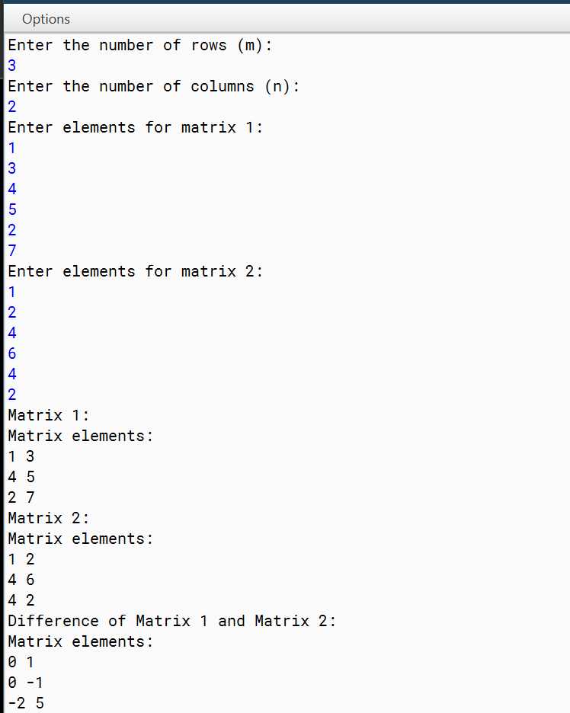
Output:

Q6)Write a program to declare a square matrix A[ ] [ ] of order (M x M) where ‘M’ is the number of rows and the number of columns such that M must be greater than 2 and less than 10. Accept the value of M as user input. Display an appropriate message for an invalid input. Allow the user to input integers into this matrix. Perform the following
tasks:
Display the original matrix.
Check if the given matrix is Symmetric or not.
A square matrix is said to be Symmetric, if the element of the i th row and j th column is equal to the element of the j th row and i th column.
Find the sum of the elements of the left diagonal and the sum of the elements of the right diagonal of the matrix and display them.

Algorithm:
STEP 1: START
STEP 2: INITIALIZE size, array arr[][]
STEP 3: INPUT The value of size from the user, which is the size of the square matrix arr[][]
STEP 4: Check if M is less than or equal to 2 or greater than or equal to 10. If true, display an error message stating that the input is invalid, and terminate the program.
STEP 5: Find the transpose of the matrix arr[][](assume tarr[][]) STEP 6: run a loop to check if arr[a][b] = tarr[a][b]
//arr[a][b] = element at ath row, bth column
//tarr[a][b] = element at ath row, bth column
STEP 7: If the checking in entire loop holds true then declare “matrix is symmetric” STEP 8: Calculate the sum of the elements in the left diagonal(assume l)
STEP 9: Calculate the sum of the elements in the right diagonal(assume r) STEP 10: PRINT l, r
STEP 11: STOP

Source Code:
import java.util.Scanner; class Matrix
{
int[][] arr; int size;
Matrix(int size)
{
this.size = size;
arr = new int[size][size];
}
public void fillMatrix()//Inputting the elements of matrix
{
Scanner scanner = new Scanner(System.in); System.out.println("Enter the elements of the matrix:"); for (int i = 0; i < size; i++)
{
for (int j = 0; j < size; j++)
{
arr[i][j] = scanner.nextInt();
}
}
}
public void displayMatrix()//Displaying the matrix
{
System.out.println("Original Matrix:"); for (int i = 0; i < size; i++)
{
for (int j = 0; j < size; j++)
{
System.out.print(arr[i][j] + " ");
}
System.out.println();
}
}
public boolean isSymmetric()//Checking if the matrix is symmetric
{
for (int i = 0; i < size; i++)
{
for (int j = 0; j < size; j++)
{
if (arr[i][j] != arr[j][i])
{
return false;
}
}
}
return true;

}
public int sumLeftDiagonal()//Calculates the elements in left diagonal
{
int sum = 0;
for (int i = 0; i < size; i++)
{
sum += arr[i][i];
}
return sum;
}
public int sumRightDiagonal()//Calculates the elements in right diagonal
{
int sum = 0;
for (int i = 0; i < size; i++)
{
sum += arr[i][size - 1 - i];
}
return sum;
}
public static void main(String[] args)
{
Scanner scanner = new Scanner(System.in); System.out.println("Enter the size of the square matrix (M):"); int M = scanner.nextInt();
if (M <= 2 || M >= 10)
{
System.out.println("Invalid input! M must be greater than 2 and less than 10."); return;
}
Matrix matrix = new Matrix(M); matrix.fillMatrix(); matrix.displayMatrix();
if (matrix.isSymmetric())
{
System.out.println("The matrix is symmetric.");
}
else
{
System.out.println("The matrix is not symmetric.");
}
int sumLeftDiagonal = matrix.sumLeftDiagonal(); int sumRightDiagonal = matrix.sumRightDiagonal();
System.out.println("Sum of the elements of the left diagonal: " + sumLeftDiagonal); System.out.println("Sum of the elements of the right diagonal: " + sumRightDiagonal);
}
}

VDT:

Variable | Datatype | Function
arr[][] | int | Stores the integer value
size | int | Stores the size of array
sum | int | Stores the sum of diagonals
M | int | Stores the size of array
sumLeftDiagonal | int | Stores the sum of left diagonal
sumLeftDiagonal | int | Stores the sum of right diagonal
i | int | Stores the integer value used in loop
j | int | Stores the integer value used in loop

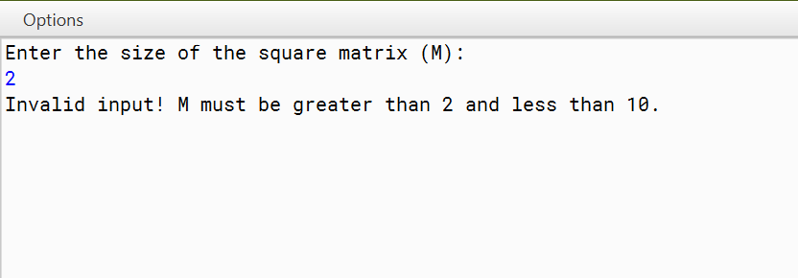
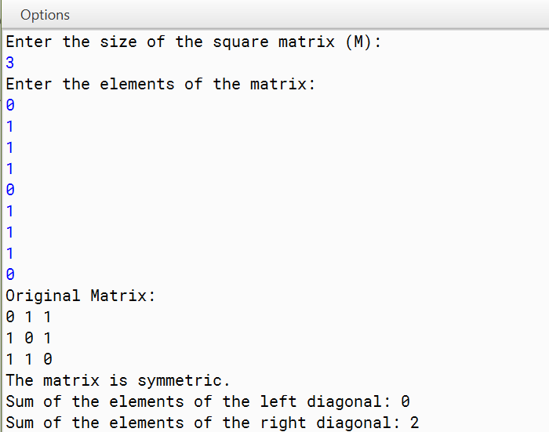
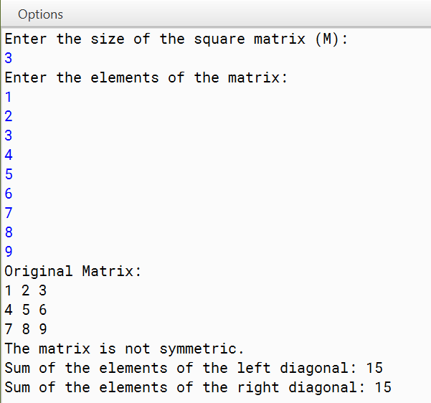
Output:

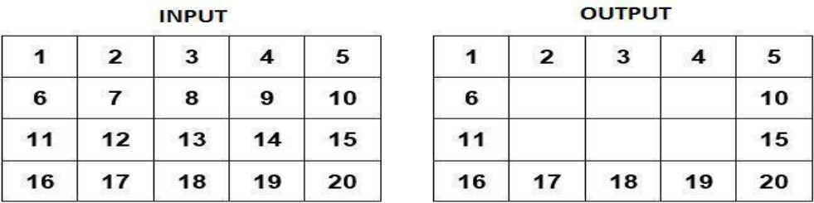
Q7)Write a Program in Java to input a 2-D array of size ‘m*n’ and print its boundary (border) elements.

Algorithm:
STEP 1: START
STEP 2: INITIALIZE M, N, array arr[][]
STEP 3: Read and store the value of the number of rows.(M) STEP 4: Read and store the value of the number of columns.(N) STEP 5: Input the elements of the matrix from the user.
STEP 6: Display the original matrix.
STEP 7: Replace elements except the border elements of arr[][] with “\t “ STEP 8: Display a message stating "Matrix with border elements only." STEP 9: Display the modified matrix.
STEP 10: STOP

Source Code:
import java.util.Scanner; class BorderMatrix
{
String[][] arr; int M;
int N;
BorderMatrix(int m, int n)//Parameterised constructor
{
M = m; N = n;
arr = new String[M][N];
}
public void fillMatrix()//Inputting elements
{
Scanner scanner = new Scanner(System.in); System.out.println("Enter the elements of the matrix:"); for (int i = 0; i < M; i++)
{
for (int j = 0; j < N; j++)
{
arr[i][j] = scanner.next()+"\t";//Tabular format
}
}
}
public void displayMatrix()//Displaying matrix
{
for (int i = 0; i < M; i++)
{
for (int j = 0; j < N; j++)
{
System.out.print(arr[i][j] + " ");
}
System.out.println();
}
}
void borderMatrix()//Function to represent only border elements
{
for (int i = 1; i < M-1 ; i++)
{
for (int j = 1; j < N-1; j++)
{
arr[i][j] = "\t";//Tabular format
}
}
}
public static void main(String[] args)
{

Scanner scanner = new Scanner(System.in); System.out.println("Enter the number of rows:"); int M = scanner.nextInt();
System.out.println("Enter the number of coloumns:"); int N = scanner.nextInt();
BorderMatrix obj = new BorderMatrix(M,N); obj.fillMatrix();
System.out.println("Original Matrix"); obj.displayMatrix(); obj.borderMatrix();
System.out.println("Matrix with border elements only"); obj.displayMatrix();
}
}

VDT:

Variable | Datatype | Function
arr[][] | int | Stores the integer value
M | int | Stores the no of columns
N | int | Stores the no of rows
m | int | Stores the no of columns
n | int | Stores the no of rows
i | int | Stores the integer value used in loop
j | int | Stores the integer value used in loop

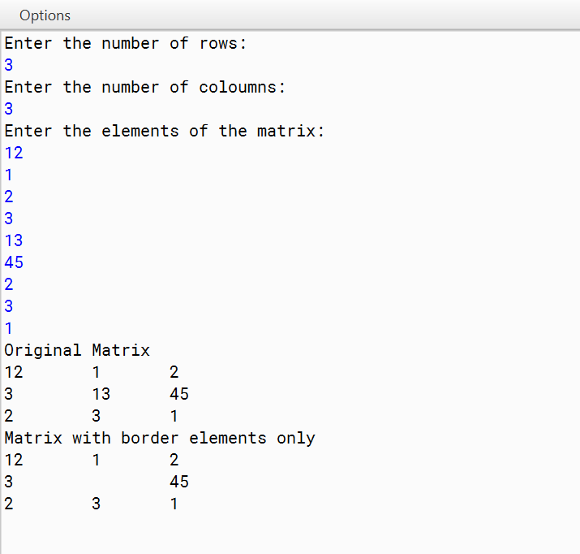
Output:

Q8)Write a program to check if the given matrix is a Magic Square Matrix or not. A square matrix is said to be a Magic Square, if the sum of each row, each column and each diagonal is the same. Write a program to enter an integer number ‘n’. Create a magic square of size ‘n*n’. Finally, print the elements of the matrix as Magic Square.

Algorithm:
STEP 1: START
STEP 2: INITIALIZE size(size of the matrix), array arr[][] STEP 3: INPUT the value of size from the user
STEP 4:For each row in the matrix, calculate the sum of the elements and store it in an array (S1). STEP 5:For each column in the matrix, calculate the sum of the elements and store it in an array (S2). STEP 6: For each column in the matrix, calculate the sum of the elements and store it in an array (S2). STEP 7: Calculate the sum of the elements in the main diagonal and store it (S3).
STEP 8: Calculate the sum of the elements in the secondary diagonal and store it (S4).
STEP 9: Check if S1, S2, S3, S4 are equal and return true if they are equal and false if they are not STEP 10: Check the value of the boolean variable (b).
//If true, display a message stating "Magic square."
//If false, display a message stating "Not a Magic square." STEP 11: STOP

Source Code:
import java.util.Scanner; class MagicMatrix
{
int[][] arr; int size;
MagicMatrix(int s)//Parameterised constructor
{
size = s;
arr = new int[size][size];
}
public void fillMatrix()//Accepting values of array
{
Scanner scanner = new Scanner(System.in); System.out.println("Enter the elements of the matrix:"); for (int i = 0; i < size; i++)
{
for (int j = 0; j < size; j++)
{
arr[i][j] = scanner.nextInt();
}
}
}
public void displayMatrix()//Displaying the array
{
for (int i = 0; i < size; i++)
{
for (int j = 0; j < size; j++)
{
System.out.print(arr[i][j] + " ");
}
System.out.println();
}
}
boolean magicMatrix()//Checks whether the given array is magic Matrix
{
int S1[] = new int[size]; boolean b = true;
for (int i = 0; i < size ; i++)
{
for (int j = 0; j < size; j++)
{
S1[i]+=arr[i][j];
}
}
int S2[] = new int[size]; for (int i = 0; i < size ; i++)
{

for (int j = 0; j < size; j++)
{
S2[i]+=arr[j][i];
}
}
int S3 = 0;
for (int j = 0; j < size; j++)
{
S3+=arr[j][j];
}
int S4 = 0;
for (int i = size-1,j = 0; i >= 0 ; i--, j++)
{
S4+=arr[i][j];
}
for (int i = 1; i < size ; i++)
{
if(S1[i] != S3 || S1[i] != S4 || S2[i] != S3 || S2[i] != S4 )
{
b = false;
}
}
return b;
}
public static void main(String[] args)//Main method
{
Scanner scanner = new Scanner(System.in); System.out.println("Enter the size:");
int Size = scanner.nextInt();
MagicMatrix obj = new MagicMatrix(Size); obj.fillMatrix();
System.out.println("Your number square:"); obj.displayMatrix();
if(obj.magicMatrix() == true)
{
System.out.println("Magic square");
}
else
{
System.out.println("Not a Magic square");
}
}
}

VDT:

Variable | Datatype | Function
arr[] | int | Stores the integer value
size | int | Stores the size of array
s | int | Stores the size of array
S1 | int | Stores the sum of rows
S2 | int | Stores the sum of column
S3 | int | Stores the sum of primary diagonal
S4 | int | Stores the sum of secondary diagonal
b | boolean | Stores true/false
i | int | Stores the integer value used in loop
j | int | Stores the integer value used in loop

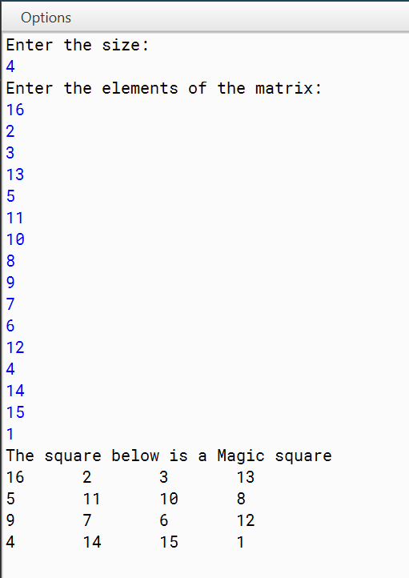
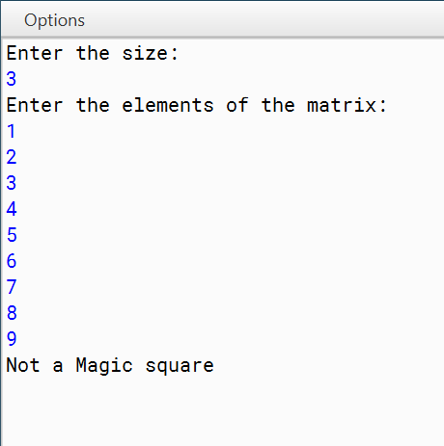
Output:

Q9)Write a program to declare a square matrix A[ ][ ] of order ‘n’. Allow the user to input positive integers into this matrix. Perform the following tasks on the matrix:
Output the original matrix.
Find the SADDLE POINT for the matrix. If the matrix has no saddle point, output the message “NO SADDLE POINT”.
[Note: A saddle point is an element of the matrix such that it is the minimum element for the row to which it belongs and the maximum element for the column to which it belongs. Saddle point for a given matrix is always unique.]

Algorithm:
STEP 1: START
STEP 2: INITIALIZE M, N, array a[][]
STEP 3: Take the input of M(number of rows), N(number of columns) STEP 4: Take the input of elements of array
STEP 5: If any input element is negative, display "Invalid Input" and exit.
STEP 6: Under a loop find the element of a row which has the least value in its column STEP 7: Check whether the same element is the highest in its row.
STEP 8: If STEP 6, 7 true then we found the saddle point STEP 9: If no such elements exist, then print no saddle point STEP 10: Print the saddle point if STEP 8 is true
STEP 11: STOP

Source Code:
import java.util.Scanner; class SaddlePoint
{
public static void main(String args[])
{
Scanner in = new Scanner(System.in); System.out.print("Enter the size of the matrix: "); int n = in.nextInt();
int a[][] = new int[n][n];
System.out.println("Enter elements of the matrix: "); for (int i = 0; i < n; i++) //Taking Input
{
System.out.println("Enter Row "+ (i+1) + " :"); for (int j = 0; j < n; j++)
{
a[i][j] = in.nextInt();
if (a[i][j] < 0)
{
System.out.print("Invalid Input"); return;
}
}
}
System.out.println("Matrix A[ ][ ]"); printMatrix(a, n, n);
//Find the Saddle Point boolean found = false;
for (int i = 0; i < n; i++) //loop changes to every row
{
int Min = a[i][0]; int check = 0;
for (int j = 1; j < n; j++) //loop changes columns and checks Min value
{
if (Min > a[i][j])
{
Min = a[i][j]; check = j;
}
}

point
int k = 0;
for (k = 0; k < n; k++) //If the Min value is lower than its corresponding column then it is not Saddle

{
if (Min < a[k][check])
{

break;
}

}
if (k == n) //Only a saddle point would have greatest value in column while having min value in its row
{
found = true;
System.out.println("Saddle Point = " + Min); break;
}
}
if (!found)
{
System.out.println("No Saddle Point");
}
}
public static void printMatrix(int arr[][], int n)//Printing
{
for (int i = 0; i < n; i++)
{
for (int j = 0; j < n; j++)
{
System.out.print(arr[i][j] + "\t");
}
System.out.println();
}
}
}

VDT:

Variable | Datatype | Function
a[][] | int | Stores the integer value
arr[][] | int | Stores the integer value
n | int | Stores the length of array
Min | int | Stores the minimum value of the element in column
check | int | Stores the column where minimum value was found
i | int | Stores the integer value used in loop
j | int | Stores the integer value used in loop

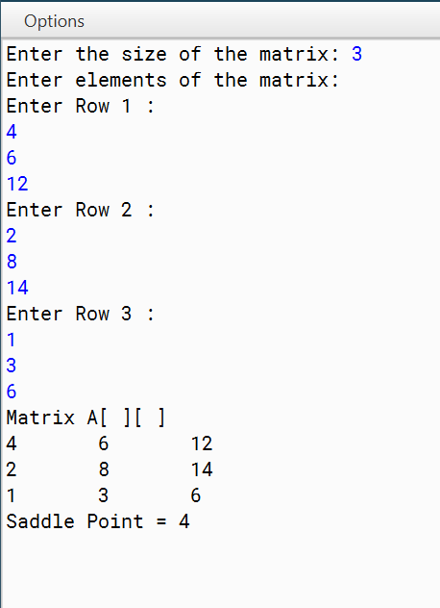
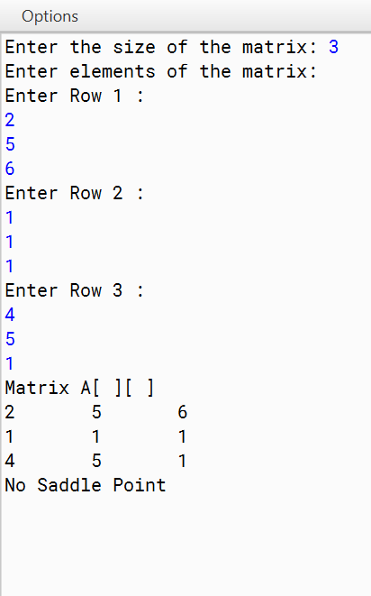
Output:

Q10)Write a Program in Java to input a 2-D square matrix and check whether it is an Upper Triangular Matrix or not.
Upper Triangular Matrix : An Upper Triangular matrix is a square matrix in which all the entries below the main diagonal () are zero. The entries above or on the main diagonal themselves may or may not be zero.

Algorithm:
STEP 1: START
STEP 2: INITIALIZE N, array Matrix[][] STEP 3: INPUT N from the user
STEP 4: Adjust the size of array Matrix[][] as N
STEP 5: INPUT the elements of the array through a loop
STEP 6: Run a loop to check whether the elements in lower triangle of the matrix is 0 STEP 7: If STEP 6 is true then
Print “Upper Triangle” STEP 8: If STEP 6 is false then
Print “Not a Upper Triangle” STEP 9: STOP

Source Code:
import java.util.Scanner; class UpperTriangle
{ int N;
int Matrix[][];
UpperTriangle(int nn)//Parameterised Constructor
{
N = nn;
Matrix = new int[nn][nn];
}
void fillMatrix()//Input the elements
{
Scanner sc = new Scanner(System.in); System.out.println("Enter the elements"); for(int i = 0; i < N; i++)
{
for(int j = 0; j < N; j++)
{
Matrix[j][i] = sc.nextInt();
}
}
}
Boolean isUpperTriangularMatrix()//Check for UpperTriangle
{
for (int i = 1; i < N ; i++)
{
for (int j = 0; j < i; j++)
{
if (Matrix[j][i] != 0)
{
return false;
}
}
}
return true;
}
void displayMatrix()//Printing the matrix
{
for(int i = 0; i < N; i++)
{
for(int j = 0; j < N; j++)
{
System.out.print(Matrix[j][i]+"\t");
}
System.out.println();
}
}
public static void main(String argc[])//Main Method

{
Scanner sc = new Scanner(System.in); System.out.println("Enter size");
int n = sc.nextInt();
UpperTriangle obj = new UpperTriangle(n); obj.fillMatrix();
if (obj.isUpperTriangularMatrix() == true)
{
System.out.println("Upper Triangle Matrix"); obj.displayMatrix();
}
else
{
System.out.println("Not an Upper Triangle Matrix"); obj.displayMatrix();
}
}
}

VDT:

Variable | Datatype | Function
Matrix[][] | int | Stores the integer value
N | int | Stores the size of array
nn | int | Stores the size of array
n | int | Stores the size of array
i | int | Stores the integer value used in loop
j | int | Stores the integer value used in loop

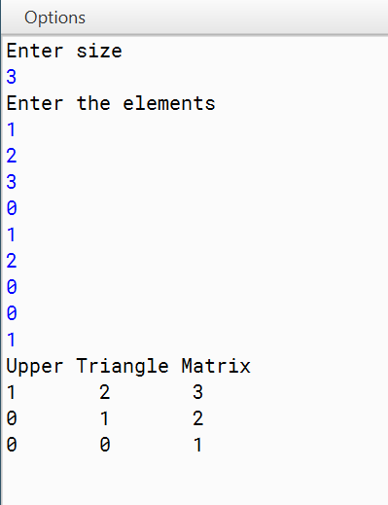
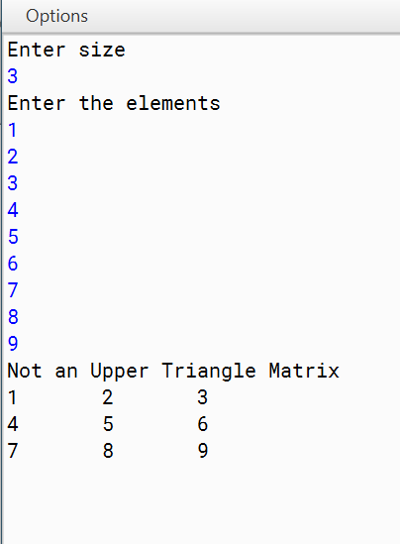
Output:

Q11)A sequence of Fibonacci Strings is generated as follows:
S₀ = “a”, S₁ = “b”, S_{n} = S_{(n-1)} + S_{(n-2)} where ‘+’ denotes concatenation. Thus the sequence is:
a, b, ba, bab, babba, babbabab, n terms.

Design a class FiboString to generate Fibonacci strings. Some of the members of the class are given below:
Class name : FiboString Data members/instance variables:
: to store the first string
: to store the second string
: to store the concatenation of the previous two strings
n : to store the number of terms Member functions/methods:
FiboString() : constructor to assign x=”a”, y=”b”, z=”ba” void accept() : to accept the number of terms ‘n’
void generate() : to generate and print the fibonacci strings. The sum of (‘+’ i.e. concatenation) first two strings is the third string. Eg. “a” is the first string, “b” is the second string then the third string will be “ba” and fourth will be “bab” and so on.

Algorithm:
STEP 1: START
STEP 2: INITIALIZE x, y, z[3 words], n STEP 3: x = "a";
STEP 4: y = "b"; STEP 5: z = "ba"
STEP 6: Accept the value of n from user STEP 7: If n = 1 then Print x
STEP 8: If n = 2 then Print x+” ”+y
STEP 9: If n = 3 or more, run a loop for (n-2)times and do print z + “ “, x = y, y = z within the loop STEP 10: STOP

Source Code:
import java.util.Scanner; class FiboString
{
String x, y, z; int n;
FiboString ()//Default Constructor
{
x = "a";
y = "b";
z = "ba";
}
void accept ()//Input the value of number of terms
{
Scanner sc = new Scanner( System.in ); System.out.print( "Enter number of terms: "); n = sc.nextInt();
}
void generate ()//Generate the string
{
if( n == 1 )
{
System.out.print ( x );//Default
}
else if( n==2 )
{
System.out.print ( x + " " + y );//Default
}
else
{
System.out.print ( x + " " + y + " ");
for( int i = 1; i <= (n-2) ; i++ )//Pattern loop for the program
{
z = y + x;
System.out.print ( z + " "); x=y;
y=z;
}
}
System.out.println ();
}
public static void main ( String args[] )//Main method
{
FiboString fs = new FiboString (); fs.accept();
fs.generate();
}
}

VDT:

Variable | Datatype | Function
x | String | Stores the String value
y | String | Stores the String value
z | String | Stores the String value
i | int | Stores the integer value used in loop

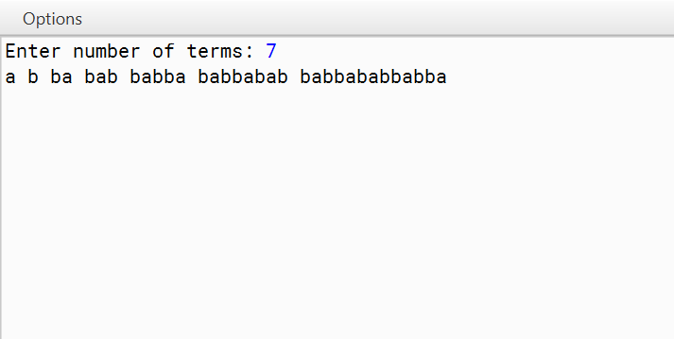
Output.

Q12)Write a program to accept a sentence which may be terminated by either ‘.’ ‘?’ or ‘!’ only. Any other character may be ignored. The words may be separated by more than one blank space and are in UPPER CASE. Perform the following tasks:
Accept the sentence and reduce all the extra blank space between two words to a single blank space.
Accept a word from the user which is part of the sentence along with its position number and delete the word and display the sentence.

Algorithm:
STEP 1: START
STEP 2: INITIALIZE str, wordCount, array strArr[] STEP 3: Accept the value of str from the user
STEP 4: Set the value of wordCount to the number of words in st
STEP 5: Using a loop and wordCount limiter, set the elements of array strArr to the word in the string one by one
STEP 6: If the sentence does not have “.”, “!” and “?” then Print “Invalid Input” STEP 7: To remove spaces run another loop and concatenate the elements of the array STEP 8: Also remove extra front and back spaces
STEP 9: Print the new String STEP 10: STOP

Source Code:
import java.util.*; class StringCheck
{
public static String sortString(String ipStr)
{
StringTokenizer st = new StringTokenizer(ipStr); int wordCount = st.countTokens();
String strArr[] = new String[wordCount]; for (int i = 0; i < wordCount; i++)
{
strArr[i] = st.nextToken();
}
StringBuffer sb = new StringBuffer(); for (int i = 0; i < wordCount; i++)
{
sb.append(strArr[i]+" ");
}
return sb.toString().trim();
}
public static void main(String args[])
{
Scanner in = new Scanner(System.in); System.out.println("Enter a sentence:"); String str = in.nextLine();
int len = str.length(); System.out.println();
char ch = str.charAt(len-1); if (str.charAt(len - 1) != '.'
&& str.charAt(len - 1) != '?'
&& str.charAt(len - 1) != '!')
{
System.out.println("INVALID INPUT"); return;
}
String sortedStr = sortString(str.substring(0, len-2))+ch; System.out.println(sortedStr);
}
}

VDT:

Variable | Datatype | Function
str | String | Stores the String value
strArr[] | String | Stores the String words in the form of elements
len | int | Stores the length of string
i | int | Stores the integer value used in loop
ch | char | Stores character values
wordCount | int | Stores the number of words

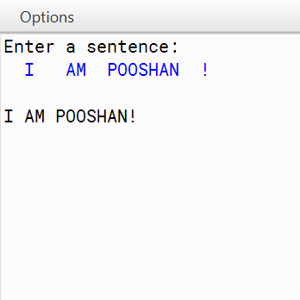
Output:

Q13)Write a program to input a word from the user and remove the consecutive repeated characters by replacing the sequence of repeated characters by its single occurrence.

Algorithm:
STEP 1: START
STEP 2: INITIALIZE sen
STEP 3: Accept the value of sen from the user
STEP 4: Add an extra space at the end of the word to handle the last character comparison. STEP 5: INITIALIZE newsen
STEP 6: Iterate over each character in the word using a loop. STEP 7: newsen = character at the given iteration + ”“
STEP 8: Within the same loop if character remains same then skip the STEP 7 function by skipping the next iteration value using while loop
STEP 9: Print newsen STEP 10: STOP

Source Code:
import java.util.Scanner;
public class RemovingConsecutives
{
public static void main(String[] args)
{
Scanner sc = new Scanner(System.in); System.out.println("Enter the word"); String sen = sc.nextLine();
sen = sen + " "; String newsen = "";
for(int i = 0; i < sen.length()-1;)
{
char c = sen.charAt(i); newsen = newsen + c +""; while(c == sen.charAt(i))
{
i++;
}
}
System.out.println(newsen);
}
}

VDT:

Variable | Datatype | Function
sen | String | Stores the String value
newsen | String | Stores the String value
c | Character | Stores the Character value
i | int | Stores the integer value used in loop

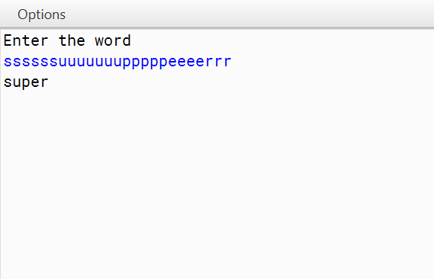
Output:

Q14)Write a program to input a string (word). Convert it into lowercase letters. Count and print the frequency of each alphabet present in the string.

Algorithm:
STEP 1: START
STEP 2: INITIALIZE sen, count STEP 3: Input value of sen from user STEP 4: Convert sen to lowercase
STEP 5: Convert sen to a sorted version of itself using selection sorting STEP 6: Use an iteration over the characters of the sorted string
STEP 7: count the number of characters in the string using the loop and print their character and frequency STEP 8: Do STEP 7 for all the different characters in the sorted string
STEP 9: To avoid printing of the same alphabet we can also replace the original character with “ ”. STEP 10: STOP

Source Code:
import java.util.Scanner; class RemovingConsecutives
{
public static void main(String[] args)
{
RemovingConsecutives obj = new RemovingConsecutives(); Scanner sc = new Scanner(System.in); System.out.println("Enter the word");
String sen = sc.nextLine(); sen = sen.toLowerCase(); sen = obj.sortedString(sen); String s;
int count = 0; System.out.println("Alphabet\tfrequency");
for(int i = 0; i < sen.length(); i++)//loop to find frequency and then print it
{
char c = sen.charAt(i);
for(int j = 0; j < sen.length(); j++)
{
if(sen.charAt(j) == c && sen.charAt(j)!= ' ')
{
count++;
}
}
if(count > 0)//so that we do not print “ “
{
System.out.println(c+"\t\t"+count);
}
s=c+"";
sen = sen.replace(s," ");//so that we do not print the same alphabet count = 0;
}
}
String sortedString(String s)//Sorting the string but maintaining its frequency
{
String ns = ""; int pos = 0;
char tmp, small;
char c[] = new char[s.length()]; for(int i =0; i < s.length(); i++)
{
c[i] = s.charAt(i);
}
for(int i = 0; i < c.length; i++)//Selection sort
{
small = c[i];
for(int j = i+1; j < c.length; j++)

{
if(c[j] < small)
{
small = c[j]; pos = j;
}
}
tmp = c[i]; c[i] = c[pos]; c[pos] = tmp;
}
for(int i = 0; i < s.length(); i++)
{
ns = ns+c[i];
}
return ns;
}
}

VDT:

Variable | Datatype | Function
sen | String | Stores the String value
s | String | Stores the String value of the character
count | String | Stores the integer value
i | int | Stores the integer value used in loop
tmp | char | Stores the Character value
pos | int | Stores the integer value
small | char | Stores the Character value

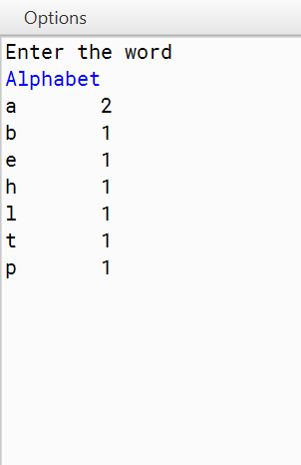
Output:

Q15)A class Merger concatenates two positive integers that are greater than 0 and produces a newly
merged integer.
Example: If the first number is 23 and the second is 764, then the concatenated number will be
23764.
Some of the members of the class are given below:
Class name: Merger
Data members/instance variables:
n1: long integer to store the first number n2: long integer to store the second number
mergNum: long integer to store the merged number Member functions:
Merger(): constructor to initialize the data members
void readNum(): to accept the values of the data members n1 and n2 voidjoinNum(): to concatenate the numbers n1 and n2 and store it in mergNum
void show(): to display the original numbers and the merged number with appropriate messages
Specify the class Merger giving the details of the constructor, void readNum(), void joinNum()
and void show(). Define the main() function to create an object and call the functions accordingly
to enable the task.

Algorithm:
STEP 1: START
STEP 2: INITIALIZE n1, n2, mergNum
STEP 3: Accept the value of n1 from the user STEP 4: Accept the value of n2 from the user STEP 5: convert n1 to string
STEP 6: convert n2 to string STEP 7: Concatenate n1 and n2
STEP 8: Convert the concatenated value to long and equate it to mergNum STEP 9: Print mergNum
STEP 10: STOP

Source Code:
import java.util.Scanner; class Merger
{
long n1 , n2 , mergNum; Merger()//Default constructor
{
n1 = 0;
n2 = 0;
mergNum = 0;
}
void readNum()//Function for accepting value
{
Scanner s = new Scanner(System.in); System.out.println("Enter First Number:"); n1 = s.nextLong();
System.out.println("Enter Second Number"); n2 = s.nextLong();
}
void JoinNum()//Merging the 2 numbers
{
if(n1>0 && n2>0)//to accept only positive numbers
{
String s1 = Long.toString(n1); String s2 = Long.toString(n2); String s3 = s1 + s2;
mergNum = Long.valueOf(s3);
}
else
{
System.out.println("Numbers should be positive");
}
}
void show()//Printing the merged number
{
System.out.println("First Number : "+n1); System.out.println("Second Number : "+n2); System.out.println("Merged Number : "+mergNum);
}
public static void main(String[] args)
{
Merger obj = new Merger(); obj.readNum(); obj.JoinNum();
obj.show();
}}

VDT:

Variable | Datatype | Function
s1 | String | Stores the String value
s2 | String | Stores the String value
s3 | String | Stores the String value
n1 | long | Stores the integer value
n2 | long | Stores the integer value
n3 | long | Stores the integer value

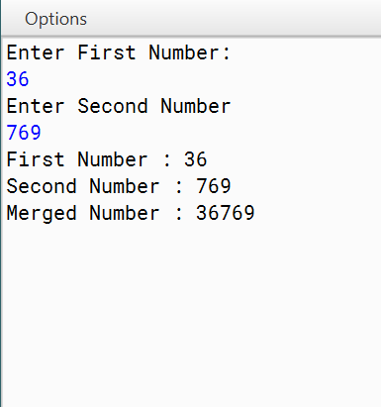
Output:

Q16)A class SeriesSum is designed to calculate the sum of the following series:-
Sum= x2/1! + x4/3!+x6/5!+….xn/(n-1)!
Some of the members of the class are given below:
Class name : SeriesSum

Data members
x : to store an integer number
n : to store number of terms
sum : double variable to store the sum of the series
Member functions :
SeriesSum(intxx,intnn) : constructor to assign x=xx, n=nn
double findfact(int m) : to return the factorial of m using recursive technique void calculate() : to calculate the sum of the series by invoking the recursive functions repeatedly
void display() : to display the sum of the series

Specify the class SeriesSum, giving details of the constructor(int,int), double findfact(int), double findpower(int,int), void calculate() and void display().
Define the main() function to create an object and call the functions accordingly to enable the task.

Algorithm:
STEP 1: START
STEP 2: Read or initialize the values for `x` (integer) and `n` (number of terms).
STEP 3: Create an object of the `SeriesSum` class using the constructor with the values of `x` and `n`. STEP 4: Define a recursive function `findfact(m)` to calculate the factorial of `m`.
STEP 5: Define a recursive function `findpower(base, exp)` to calculate `base` raised to the power `exp`. STEP 6: Initialize the `sum` variable to 0.0.
STEP 7: Loop from 1 to `n` to calculate each term of the series, Compute the exponent for the current term, Calculate the term using `findpower` and `findfact`, Add the term to `sum`.
STEP 8: Invoke the `calculate()` method of the `SeriesSum` object to compute the sum of the series. STEP 9: Invoke the `display()` method of the `SeriesSum` object to print the sum of the series.
STEP 10: STOP

Source Code:
public class SeriesSum {
// Data members private int x; private int n; private double sum;

// Constructor to assign x and n public SeriesSum(int xx, int nn) {
x = xx; n = nn;
sum = 0.0;
}

// Recursive method to find the factorial of m public double findfact(int m) {
if (m == 0 || m == 1) { return 1;
} else {
return m * findfact(m - 1);
}
}

// Recursive method to find the power of base^exp public double findpower(int base, int exp) {
if (exp == 0) { return 1;
} else {
return base * findpower(base, exp - 1);
}
}

// Method to calculate the sum of the series public void calculate() {
int exponent = 2; // Initial exponent value for (int i = 1; i <= n; i++) {
double term = findpower(x, exponent) / findfact(exponent - 1); sum += term;
exponent += 2; // Increment exponent by 2 for each term
}
}

// Method to display the sum of the series public void display() {
System.out.println("The sum of the series is: " + sum);
}

// Main method to test the SeriesSum class

public static void main(String[] args) {
SeriesSum series = new SeriesSum(2, 5); // Example values for x and n series.calculate();
series.display();
}
}

VDT:
Variable Name | Datatype | Function
x | int | Stores integral Value
n | int | Stores integral Value
sum | double | Stores Double Value
m | int | Stores integral Value
base | int | Stores integral Value
exp | int | Stores integral Value
exponent | int | Stores integral Value
term | double | Stores Double Value


Output:

Q17)A class RecFact defines a recursive function to find the factorial of a number. The details of the class are given below:
Class Name : RecFact
Data Members :
n : stores the number whose factorial is required.
r : stores an integer
Member functions :
RecFact() : default constructor
void readnum() : to enter values for n and r.
int factorial(int) : returns the factorial of the number using the recursive
technique.
voidfactseries() : to calculate and display the value of
n!
-----------------
r! * (n-r)!
Specify the class RecFact giving the details of the constructor and member functions void readnum(), int factorial(int) and void factseries(). Also define the main function to create an object and call methods accordingly to enable the task.

Algorithm:
STEP 1: START
STEP 2: Define class RecFact with private instance variables n and r. STEP 3: Implement a default constructor initializing n and r to 0.
STEP 4: Create a method readnum() to input values for n and r.
STEP 5: Develop a recursive function factorial(num) to calculate factorial. STEP 6: Write a method factseries() to compute and display n! * (n-r)!.
STEP 7: In the main method, create an object of RecFact. STEP 8: Call readnum() to input values for n and r.
STEP 9: Call factseries() to perform the calculation and display the result. STEP 10: STOP

Source Code:
import java.util.Scanner;

public class RecFact {
private int n; // stores the number whose factorial is required private int r; // stores an integer

// Default constructor public RecFact() {
n = 0;
r = 0;
}

// Member function to read values for n and r public void readnum() {
Scanner scanner = new Scanner(System.in); System.out.print("Enter the value of n: "); n = scanner.nextInt(); System.out.print("Enter the value of r: "); r = scanner.nextInt();
}

// Recursive function to calculate factorial public int factorial(int num) {
if (num == 0 || num == 1) return 1;
else
return num * factorial(num - 1);
}

// Function to calculate and display the value of n! * (n-r)! public void factseries() {
int result = factorial(n) / (factorial(r) * factorial(n - r)); System.out.println("n! /r! (n-r)! = " + result);
}

public static void main(String[] args) { RecFact obj = new RecFact(); obj.readnum();
obj.factseries();
}
}

VDT:
Variable Name | Datatype | Function
n | int | Stores integral Value
r | int | Stores integral Value

Output:

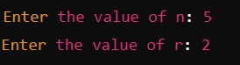


Q18)An emirp number is a number which is prime backwards and forwards.
Example: 13 and 31 are
both prime numbers. Thus, 13 is an emirp number.
Design a class Emirp to check if a given number is Emirp number or not.
Some of the members
of the class are given below:
Class name: Emirp
Data members/instance variables:
n: stores the number
rev: stores the reverse of the number f: stores the divisor
Member functions:
Emirp(int nn): to assign n = nn, rev = 0 and f = 2
int isprime(int x): check if the number is prime using the recursive technique and return 1 if prime otherwise return 0
void isEmirp(): reverse the given number and check if both the original number and the reverse number are prime, by invoking the function isprime(int) and display the result with an appropriate message
Specify the class Emirp giving details of the constructor(int), int isprime (int) and void isEmirp().
Define the main function to create an object and call the methods to check for an Emirp number.

Algorithm:
STEP 1: START
STEP 2: INITIALIZE n
STEP 3: Input the value of n from user STEP 4: Check if n is prime
STEP 5: IF n is prime, then set c = 1 STEP 6: Find the reverse of n
STEP 7: Check if the reverse of n is prime
STEP 8: If the reverse of n is prime, then set c1 = 1
STEP 9: IF c & c1 are equal to 1, then print “Emirp number”, else print “Not Emirp number” STEP 10: STOP

Source Code:
import java.util.Scanner; public class Emirp
{
int n,rev,f;
Emirp(int nn)//Parameterised constructor
{
n=nn; rev=0; f=2;
}
int isprime(int x)//Checks a number whether it is a prime number or not
{
int c = 1;
for(int i = f; i < x/2; i++)
{
if(x%i == 0)
{
c = 0;
}
}
return c;
}
void isEmirp()//Checks a number whether it is a emirp number or not
{
int x=n;
while(x!=0)//finds reverse of number
{
rev=(rev*10)+x%10; x=x/10;
}
if(isprime(x)==1 && isprime(rev)==1)
{
System.out.println(n+" is an Emirp number");
}
else
{
System.out.println(n+" is not an Emirp number");
}
}
public static void main()//Main method
{
Scanner sc=new Scanner(System.in); System.out.println("Enter a number"); int x=sc.nextInt();
Emirp obj=new Emirp(x); obj.isEmirp();
}}

VDT:

Variable | Datatype | Function
n | int | Stores the integer value
x | int | Stores the integer value
nn | int | Stores the integer value
rev | int | Stores the integer value of the reverse number
f | int | Stores the integer value
i | int | Stores the integer value used in loop

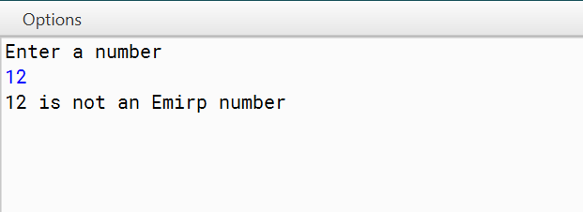
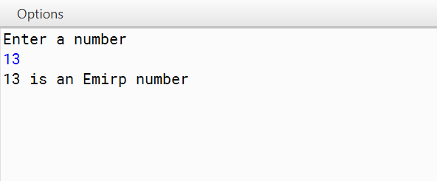
Output:

Q19) Design a class VowelWord to accept a sentence and calculate the frequency of words that begin with a vowel. The words in the input string are separated by a single blank space and terminated by a full stop.
The description of the class is given below:
Class Name : VowelWord Data members
str : to store a sentence
freq : to store the frequency of words beginning with a vowel.
Member functions
VowelWord() : constructor to initialize data members to legal initial values.
Void readstr() : to accept a sentence.
void freq_vowel( ) : counts the frequency of the words beginning with a vowel.
void display() : to display the original string and the frequency of the words that begin with a vowel.
Specify the class VowelWord giving details of the constructor( ), void readstr(), void freq_vowel() and void display(). Also defing the main function to create an object and call the methods accordingly to enable the task.

Algorithm:
STEP 1: START
STEP 2: Define a class named VowelWord.
STEP 3: Declare private instance variables str (String) and freq (int).
STEP 4: Implement a constructor VowelWord() initializing str to empty string and freq to 0.
STEP 5: Create a method readstr() to accept a sentence terminated by a full stop and store it in str. STEP 6: Implement a method freq_vowel() to count the frequency of words beginning with a vowel.
STEP 7: Implement a method display() to show the original sentence and the frequency of words beginning with a vowel.
STEP 8: Define the main method.
STEP 9: Inside the main method, create an object of the VowelWord class.
STEP 10: Call the readstr(), freq_vowel(), and display() methods on the object sequentially. STEP 11: STOP

Source Code:
import java.util.Scanner;

public class VowelWord {
private String str; // to store a sentence
private int freq; // to store the frequency of words beginning with a vowel

// Constructor to initialize data members to legal initial values public VowelWord() {
str = ""; freq = 0;
}

// Method to accept a sentence public void readstr() {
Scanner scanner = new Scanner(System.in); System.out.print("Enter a sentence terminated by a full stop: "); str = scanner.nextLine();
}

// Method to count the frequency of words beginning with a vowel public void freq_vowel() {
String[] words = str.split(" "); freq = 0;
for (String word : words) {
char firstChar = word.charAt(0); if (isVowel(firstChar)) {
freq++;
}
}
}

// Method to display the original string and the frequency of words that begin with a vowel public void display() {
System.out.println("Original string: " + str); System.out.println("Frequency of words beginning with a vowel: " + freq);
}

// Helper method to check if a character is a vowel private boolean isVowel(char ch) {
ch = Character.toLowerCase(ch);
return ch == 'a' || ch == 'e' || ch == 'i' || ch == 'o' || ch == 'u';
}

public static void main(String[] args) { VowelWord obj = new VowelWord(); obj.readstr();
obj.freq_vowel(); obj.display();
}
}

VDT:

Variable Name | Datatype | Function
str | String | Stores String Value
freq | int | Stores integral Value
words[] | String[] | Stores String Value(in array)
ch | char | Stores Character Value

Output:

Q20) Input a sentence from the user and count the number of times, the words “an” and “and” are present in the sentence. Design a class Frequency using the description given below:
Class name : Frequency Data Members
text : stores the sentence
countand : to store the frequency of the word and.
countan : to store the frequency of the word an.
len : stores the length of the string.

Member functions
Frequency() : constructor to initialize the data variables. void accept(String n) : to assign n to text where the value of the parameter should be in lowercase.
void checkandfreq(int) : to count the frequency of and using recursive technique.
void checkanfreq(int) : to count the frequency of an using recursive technique.
void display() : to display the frequency of “an” and “and” with
suitable messages.
Specify class Frequency giving details of the constructor(), void accept(String), void checkandfreq(), checkanfreq() and void display(). Also define the main function to create an object and call methods accordingly to enable the task.

Algorithm:
STEP 1: START
STEP 2: Define a class named Frequency.
STEP 3: Declare private instance variables text (String), countand (int), countan (int), and len (int).
STEP 4: Implement a constructor Frequency() initializing text, countand, countan, and len to empty string, 0, 0, and 0 respectively.
STEP 5: Create a method accept(String n) to assign n to text where the value of the parameter should be in lowercase.
STEP 6: Create a method checkandfreq(int index) to count the frequency of "and" using recursive technique. STEP 7: Create a method checkanfreq(int index) to count the frequency of "an" using recursive technique.
STEP 8: Create a method display() to display the frequency of "an" and "and" with suitable messages. STEP 9: Define the main method.
STEP 10: Inside the main method, accept a sentence from the user, create an object of the Frequency class, call accept(), checkandfreq(), checkanfreq(), and display() methods sequentially.
STEP 11: STOP

Source Code:
import java.util.Scanner;

public class Frequency {
private String text; // stores the sentence
private int countand; // to store the frequency of the word "and" private int countan; // to store the frequency of the word "an" private int len; // stores the length of the string

// Constructor to initialize the data variables public Frequency() {
text = ""; countand = 0;
countan = 0;
len = 0;
}

// Method to assign n to text where the value of the parameter should be in lowercase public void accept(String n) {
text = n.toLowerCase(); // Convert input to lowercase len = text.length(); // Calculate the length of the string
}

// Method to count the frequency of "and" using recursive technique public void checkandfreq(int index) {
if (index >= len - 3) // Base case: stop recursion if the remaining substring length is less than 3 return;

if (text.substring(index, index + 3).equals("and")) { countand++; // Increment count if "and" is found
}

// Recursively check the next substring checkandfreq(index + 1);
}

// Method to count the frequency of "an" using recursive technique public void checkanfreq(int index) {
if (index >= len - 2) // Base case: stop recursion if the remaining substring length is less than 2 return;

if (text.substring(index, index + 2).equals("an")) { countan++; // Increment count if "an" is found
}

// Recursively check the next substring checkanfreq(index + 1);
}

// Method to display the frequency of "an" and "and" with suitable messages public void display() {
System.out.println("Frequency of 'an': " + countan); System.out.println("Frequency of 'and': " + countand);
}

public static void main(String[] args) { Scanner scanner = new Scanner(System.in); System.out.print("Enter a sentence: "); String sentence = scanner.nextLine();

Frequency obj = new Frequency(); obj.accept(sentence); obj.checkandfreq(0); obj.checkanfreq(0);
obj.display();
}
}

VDT:

Variable Name | Datatype | Function
len | int | Stores integral Value
indes | int | Stores integral Value
text | String | Stores String Value
countand | int | Stores integral Value
countan | int | Stores integral Value

Output:

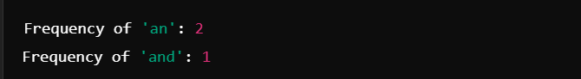

Q21)A happy number is a number in which the eventual sum of the square of the digits of the number
is equal to 1. Example:
28 = (2) 2 + (8) 2 = 4 + 64 = 68
68 = (6) 2 + (8) 2 = 36 + 64 = 100
100 = (1) 2 + (0) 2 + (0) 2 = 1 + 0 + 0 = 1
Hence, 28 is a happy number. Example:
12 = (1) 2 + (2) 2 = 1 + 4 = 5
Hence, 12 is not a happy number.
Design a class Happy to check if a given number is a happy number. Some of the members of the
class are given below:
Class name: Happy
Data Members/instance variables:
n: stores the number Member functions Happy( ): constructor to assign 0 to n.
void getnum (int nn): to assign the parameter value to the number n = nn. int sum_sq_digits (int x): returns the sum of the square of the digits of the number x
void is happy (): checks if the given number is a happy number by calling the function
sum_sq_digits(int) and displays an appropriate message.
Specify the class Happy giving details of the constructor (), void getnum (int), int sum_sq_digits
(int) and void ishappy (). Also define a main function to create an object and call the methods to check for a happy number.

Algorithm:
STEP 1: START
STEP 2: INITIALIZE n, x
STEP 3: Input the value of n from the user STEP 4: Equate x to be n
STEP 5: While x is not equal to 1 or 4, equate x to its sum of square of digits STEP 6: If x = 1, print “Happy Number”
STEP 7: If x = 4, print “Not a Happy number” STEP 8: STOP

Source Code:
import java.util.Scanner; public class Happy
{
int n;
Happy()//Non-parameterised constructor
{
n=0;
}
void getnum(int nn)//Inputting the value
{
n=nn;
}
int sum_sq_digits(int x)//Finding the square of digits
{
if(x==0)
{
return 0;
}

else
{
int rem=x%10;
return (rem * rem)+sum_sq_digits(x/10);
}
}
void ishappy()//Checking for happy number
{
int x=n;
while(x!=1 && x!=4)
{
x=sum_sq_digits(x);
}
if(x==1)
{
System.out.println(n+" IS A HAPPY NUMBER");
}
else
{
System.out.println(n+" IS NOT A HAPPY NUMBER");
}
}
public static void main()//Main method
{
Scanner sc=new Scanner(System.in); System.out.println("Enter a number"); int a=sc.nextInt();
Happy ob1=new Happy( );

ob1.getnum(a); ob1.ishappy();
}
}

VDT:

Variable | Datatype | Function
n | int | Stores the integer value
nn | int | Stores the integer value
x | int | Stores the integer value
a | int | Stores the integer value
rem | int | Stores the integer value of the remainder

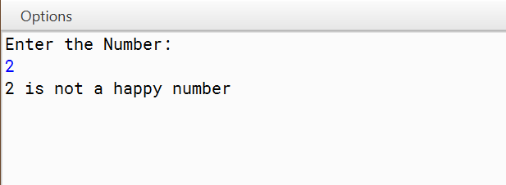
Output:

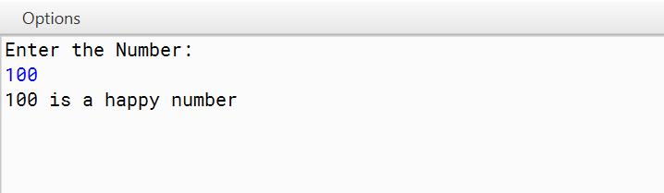

Q22. A class Employee contains employee details and another class Salary calculates the employee’s net salary. The details of the two classes are given below:
Class name : Employee
Data members :
empNo : stores the employee number.
empName : stores the employee name
empDesig : stores the employee’s designation.
Member functions:
Employee() : default constructor.
Employee(…) : parameterized constructor to assign values to data members.
void display() : display the employee details.

Class name : Salary
Data members :
basic : float variable to store the basic pay.
Member functions :
Salary(…) : parameterized constructor to assign values to data members.
void calculate() : calculates the employee’s net salary according to the
following rules:
DA = 10% of basic
HRA = 15% of basic
Salary = basic + DA +H RA
PF= 8 % of Salary
Net Salary = Salary –PF
Display the employee details and the Net salary.

Specify the class Employee giving details of the constructors and member function void display(). Using the concept of inheritance specify the class Salary giving details of the constructor and the member function void calculate(). The main function need not be written.

Algorithm:
Step 1: Start
Step 2: Define a class Employee with data members: empNo, empName, empDesig, and methods:
- Default constructor Employee()
- Parameterized constructor Employee(empNo, empName, empDesig)
- Method display() to display employee details
Step 3: Define a class Salary that inherits from Employee with an additional data member basic and methods:
- Default constructor Salary()
- Parameterized constructor Salary(empNo, empName, empDesig, basic)
- Method calculate() to calculate net salary based on basic pay:
- Declare variables DA, HRA, salary, PF, and netSalary
- Compute DA as 10% of basic
- Compute HRA as 15% of basic
- Compute salary as basic + DA + HRA
- Compute PF as 8% of salary
- Compute netSalary as salary - PF
- Display employee details and netSalary
Step 4: Input employee details: empNo, empName, empDesig, and basic pay
Step 5: Create an object of Salary class with the input employee details
Step 6: Invoke the calculate() method to calculate and display the net salary
Step 7: Stop

Source Code:
import java.util.Scanner;

class Employee {
int empNo;
String empName;
String empDesig;

Employee() {}

Employee(int empNo, String empName, String empDesig) {
this.empNo = empNo;
this.empName = empName;
this.empDesig = empDesig;
}

void display() {
System.out.println("Employee Number: " + empNo);
System.out.println("Employee Name: " + empName);
System.out.println("Employee Designation: " + empDesig);
}
}
class Salary extends Employee {
float basic;

Salary() {}

Salary(int empNo, String empName, String empDesig, float basic) {
super(empNo, empName, empDesig);
this.basic = basic;
}

void calculate() {
float DA = 0.1f * basic;
float HRA = 0.15f * basic;
float salary = basic + DA + HRA;
float PF = 0.08f * salary;
float netSalary = salary - PF;

System.out.println("Employee Details:");
display();
System.out.println("Net Salary: " + netSalary);
}
}

public class Main {
public static void main(String[] args) {
Scanner scanner = new Scanner(System.in);

System.out.println("Enter Employee Number:");
int empNo = scanner.nextInt();
scanner.nextLine(); // Consume newline
System.out.println("Enter Employee Name:");
String empName = scanner.nextLine();
System.out.println("Enter Employee Designation:");
String empDesig = scanner.nextLine();
System.out.println("Enter Basic Pay:");
float basic = scanner.nextFloat();

Salary salary = new Salary(empNo, empName, empDesig, basic);
salary.calculate();

scanner.close();
}
}

Variable | Data type | Description
empNo | int | Employee number
empName | String | Employee name
empDesig | String | Employee designation
basic | float | Basic pay of the employee
scanner | Scanner | Scanner object to read input from the console
salary | Salary | Object of the Salary class
DA | float | Dearness Allowance
HRA | float | House Rent Allowance
PF | float | Provident Fund
netsalary | float | Net salary after deductions

Output:
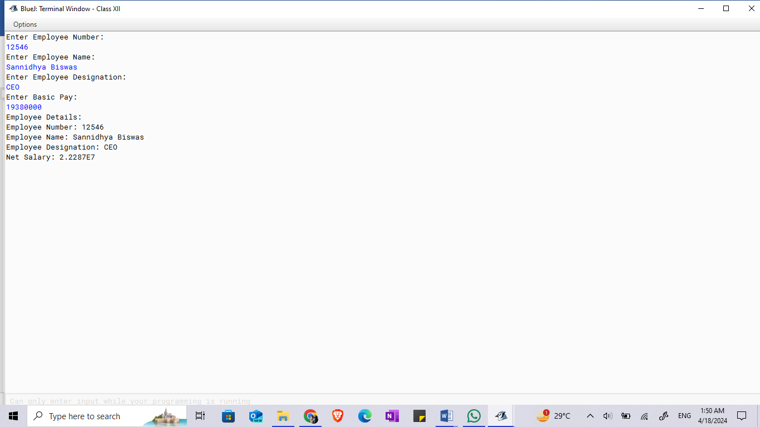
Q23. A super class Worker has been defined to store the details of a worker. Define a sub class Wages to compute the monthly wages for the worker. The details of both the classes are given below:
Class name : Worker
Data members :
name : to store the name of the worker
basic : to store the basic pay in decimal
Member functions :
Worker(….) : parameterized constructor to assign values to the instance
variables
void display() : display worker details

Class name : Wages
Data members :
hrs : stores the hours worked
rate : stores rate per hour
wage : stores the overall wage of the worker
Member functions
Wages(….) : parameterized constructor to assign values to the instance
variables of both classes
double overtime( ) : calculates and returns the overtime amount as (hours * rate )
void display() : calculates the wage using the formula
wage=overtime amount + basic pay and displays it along with
other details

Specify the class Worker giving details of the constructor() and void display(). Using the concept of inheritance, specify the class Wages giving details of the constructor(), double overtime() and void display(). The main function need not be written.

Algorithm:
1. Start
2. Define class Worker:
- Data members: name (String), basic (double)
- Constructor Worker(name, basic)
- Method display()
3. Define class Wages extending Worker:
- Data members: hrs (double), rate (double), wage (double)
- Constructor Wages(name, basic, hrs, rate)
- Method overtime() returns double
- Method display()
4. In Wages class, implement overtime() to calculate overtime amount as (hrs * rate)
5. In Wages class, implement display() to calculate wage using the formula wage = overtime() + basic, and display worker details along with wage
6. End

Source Code:
class Worker {
String name;
double basic;

Worker(String name, double basic) {
this.name = name;
this.basic = basic;
}

void display() {
System.out.println("Name: " + name);
System.out.println("Basic Pay: " + basic);
}
}

class Wages extends Worker {
double hrs;
double rate;
double wage;

Wages(String name, double basic, double hrs, double rate) {
super(name, basic);
this.hrs = hrs;
this.rate = rate;
}

double overtime() {
return hrs * rate;
}

void display() {
double overtimeAmount = overtime();
wage = overtimeAmount + basic;
super.display();
System.out.println("Wage: " + wage);
}
}

VDT:
Variable | Data Type | Description
name | String | Name of the worker
basic | Double | Basic pay of the worker
hrs | Double | Hours worked
rate | Double | Rate per hour
wage | Double | Overall wage of the worker
overtime | Method | Calculates and returns the overtime amount
display | Method | Displays worker details and wage

Output:
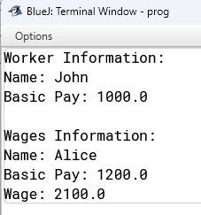

Q24. A super class Record has been defined to store the names and ranks of 50 students. Define a sub class Rank to find the highest rank along with the name. The details of both classes are given below:

Class name : Record
Data members
name[] : to store the names of students
rnk[] : to store the ranks of students
Member functions :
Record() : constructor to initialize data members
void readvalues() : to store names and ranks
void display() : displays the names and the corresponding ranks

Class name : Rank
Data members
index : integer to store the index of the topmost rank
Member functions
Rank() : constructor to invoke the base class constructor and to
initialize index to 0.
void highest() : finds the index location of the topmost rank and stores it in
index without sorting the array
void display() : displays the name and ranks along with the name having the
topmost rank.
Specify the class Record giving details of the constructor(), void readvalues(), void display(). Using the concept of inheritance, specify the class Rank giving details of constructor(), void highest() and void display(). The main function and algorithm need not be written.

Algorithm:
1. Start
2. Define class Record:
- Data members: name[] (String array), rnk[] (int array)
- Constructor Record()
- Method readvalues() to input names and ranks
- Method display() to display names and ranks
3. Define class Rank extending Record:
- Data member: index (int)
- Constructor Rank() invokes base class constructor and initializes index to 0
- Method highest() to find index location of topmost rank
- Method display() to display name and rank of the student with the topmost rank
4. End

Source Code:
import java.util.Scanner;

public class Record {
String[] name;
int[] rnk;

Record() {
name = new String[5];
rnk = new int[5];
}

void readvalues() {
Scanner scanner = new Scanner(System.in);
for (int i = 0; i < 5; i++) {
System.out.print("Enter name for student " + (i + 1) + ": ");
name[i] = scanner.nextLine();
System.out.print("Enter rank for student " + (i + 1) + ": ");
rnk[i] = scanner.nextInt();
scanner.nextLine(); // Consume newline character
}
}

void display() {
System.out.println("Name\tRank");
for (int i = 0; i < 5; i++) {
System.out.println(name[i] + "\t" + rnk[i]);
}
}
}

class Rank extends Record {
int index;

Rank() {
super();
index = 0;
}

void highest() {
int highestRank = rnk[0];
for (int i = 1; i < rnk.length; i++) {
if (rnk[i] < highestRank) {
index = i;
highestRank = rnk[i];
}
}
}

void display() {
highest();
System.out.println("Student with the highest rank:");
System.out.println("Name: " + name[index]);
System.out.println("Rank: " + rnk[index]);
}
}

class Main {
public static void main(String[] args) {
Rank rank = new Rank();
rank.readvalues();
rank.display();
}}
VDT:
name[] | String[] | Array to store names of students
mk[] | int[] | Array to store ranks of students
index | int | Index location of topmost rank
highest() | Method | Finds index location of topmost rank
display() | Method | Displays name and rank of topmost rank
Output:

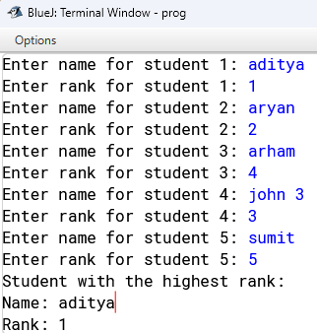

Q25. A super class Detail has been defined to store the details of a customer. Define a sub class Bill to compute the monthly telephone charge of the customer as per the chart given below:
NUMBER OF CALLS RATE
1- 100 Only rental charge
101-200 60 paisa per call + rental charge
201-300 80 paisa per call + rental charge
Above 300 1 rupee per call + rental charge

The details of both the classes are given below:

Class Name : Detail
Data members
name : to store the name of the customer.
address : to store the address of the customer.
telno : to store the phone number of the customer.
rent : to store the monthly rental charge
Member functions :
Detail(..) : parameterized constructor to assign values to data members.
void show() : to display the detail of the customer.

Class Name : Bill
Data members
n : to store the number of calls.
amt : to store the amount to be paid by the customer.
Member functions :
Bill(..) : parameterized constructor to assign values to data members of
both classes and to initialize amt = 0.0.
void cal() : calculates the monthly telephone charge as per the charge
given above.
void show() : to display the detail of the customer and amount to be paid.

Specify the class Detail giving details of the constructor( ) and void show(). Uisng the concept of inheritance, specify the class Bill giving details of the constructor( ), void cal() and void show().

Algorithm:
1. Start
2. Define class Detail:
- Data members: name (String), address (String), telno (String), rent (double)
- Constructor Detail(name, address, telno, rent)
- Method show() to display customer details
3. Define class Bill extending Detail:
- Data members: n (int), amt (double)
- Constructor Bill(name, address, telno, rent, n)
- Method cal() to calculate monthly telephone charge
- Method show() to display customer details and amount to be paid
4. End

Source Code:
class Detail {
String name;
String address;
String telno;
double rent;

Detail(String name, String address, String telno, double rent) {
this.name = name;
this.address = address;
this.telno = telno;
this.rent = rent;
}

void show() {
System.out.println("Customer Details:");
System.out.println("Name: " + name);
System.out.println("Address: " + address);
System.out.println("Telephone Number: " + telno);
System.out.println("Rent: $" + rent);
}
}

class Bill extends Detail {
int n;
double amt;

Bill(String name, String address, String telno, double rent, int n) {
super(name, address, telno, rent);
this.n = n;
amt = 0.0;
}

void cal() {
// Assuming a flat rate of $10 per telephone line per month
amt = rent + (n * 10);
}

void show() {
super.show();
System.out.println("Amount to be Paid: $" + amt);
}
}

class Main {
public static void main(String[] args) {
Bill bill = new Bill("John Doe", "123 Main St", "555-1234", 500.0, 3);
bill.cal(); // Calculate the bill
bill.show(); // Display customer details and bill amount
}
}
VDT:
Variable | Data Type | Description
name | String | Name of the customer
address | String | Address of the customer
Telno | String | Phone number of the customer
rent | double | Rent
n | int | Number of calls
amt | double | Amount to be paid by the customer
cal() | Method | Calculates monthly telephone charge
show() | Method | Display customer details and amount to pay

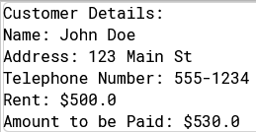
Output:

Q26. A super class Perimeter has been defined to calculate the perimeter of a parallelogram. Define a sub class Area to compute the area of the parallelogram by using the required data members of the super class. The details are given below:
Class name : Perimeter

Data Members
a : to store the length in decimal
b : to store the breadth in decimal
Member functions :
Perimeter(…) : parameterized constructor to assign values to data members
double Calculate() : calculate and return the perimeter of a parallelogram as
2 *(length +breadth)
void show() : to display the data members along with the perimeter of the
parallelogram.

Class name : Area
Data Members
h : to store the height in decimal
area : to store the area of the parallologram
Member functions :
Area(…) : parameterized constructor to assign values to data members of
both classes.
void doArea() : computes the area( breadth * height).
void show() : to display the data members of both the classes along with the
area and perimeter of the parallelogram.

Specify the class Perimeter giving details of the constructor(…), double Calculate() and void show(). Using the concept of inheritance, specify the class Area giving details of the constructor(…), void doArea() and void show(). The main function and algorithm need not be written.

Algorithm:
1. Start
2. Define class Perimeter:
- Data members: a (double), b (double)
- Constructor Perimeter(a, b)
- Method Calculate() returns double
- Method show() to display data members and perimeter of parallelogram
3. Define class Area extending Perimeter:
- Data members: h (double), area (double)
- Constructor Area(a, b, h)
- Method doArea() to compute area of parallelogram
- Method show() to display data members along with area and perimeter
4. End

Source Code:
class Perimeter {
double a;
double b;

Perimeter(double a, double b) {
this.a = a;
this.b = b;
}

double Calculate() {
return 2 * (a + b);
}

void show() {
System.out.println("Side a: " + a);
System.out.println("Side b: " + b);
System.out.println("Perimeter: " + Calculate());
}
}

class Area extends Perimeter {
double h;
double area;

Area(double a, double b, double h) {
super(a, b);
this.h = h;
}

void doArea() {
area = a * h;
}

void show() {
super.show();
doArea();
System.out.println("Height: " + h);
System.out.println("Area: " + area);
}
}

class Main {
public static void main(String[] args) {
Area parallelogram = new Area(5.0, 7.0, 8.0);
parallelogram.show();
}
}
Variable | Data Type | Description
a | double
b | double
h | double
area | double
calculate() | Method
doArea() | Method
show() | Method

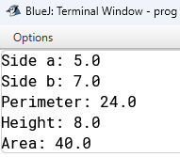
Output:

Q28)Write a program to implement LinearQ with insert(), delete() and print() methods.
Algorithm:
STEP 1: START
STEP 2: Initialize a queue with a specified size
STEP 3: Define a function to enqueue an element into the queue
STEP 4: Define a function to dequeue an element from the queue
STEP 5: Define a function to display the elements of the queue
STEP 6: Create a queue instance
STEP 7: Perform enqueue operation
STEP 8: Perform dequeue operation
STEP 9: Perform display operation
STEP 10: STOP
Source Code:
class Queue
{
int Q[]; int size;
int front, rear;
Queue(int n)\\Parameterised Constructor
{
size = n;
Q = new int[size]; rear = -1;
front = -1;
}
void enqueue(int n)\\Add element from rear
{
if(rear == size - 1)
{
System.out.print("Overflow");
}
else if(rear == -1 && front == -1)
{
front++; Q[++rear] = n;
}
else
{
Q[++rear] = n;
}
}
void dequeue()\\Add element from front
{
if(rear == -1 && front == -1)
{
System.out.print("Underflow");
}
else if(rear == front)
{
front = -1;
rear = -1;
}
else
{
front++;
}
}
void display()\\Display last element
{
if(front == -1 && rear == -1)

{
System.out.println("Empty Queue");
}
else
{
for(int i = front; i <= rear; i++)
{
System.out.print(Q[i]);
}
}
}
}
VDT:

Variable | Datatype | Function
Q | int[] | Stores the integers in array
size | int | Stores the length of array
front | int | Stores integral value
rear | int | Stores integral value
n | int | Stores integral value
x | int | Stores integral value

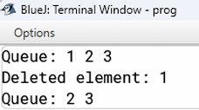
Output:

Q29) Write a program to implement Dequeue with insertfront(), insertRear(), deleteFront(), deleteRear() and print() methods.
Algorithm:
STEP 1: START
STEP 2: Initialize a deque with a specified size
STEP 3: Define a function to enqueue an element at the front of the deque
STEP 4: Define a function to enqueue an element at the back of the deque
STEP 5: Define a function to dequeue an element from the front of the deque
STEP 6: Define a function to dequeue an element from the back of the deque
STEP 7: Define a function to display the elements of the deque
STEP 8: Create a deque instance
STEP 9: Perform enqueue operation at the front
STEP 10: Perform enqueue operation at the back
STEP 11: Perform dequeue operation from the front
STEP 12: Perform dequeue operation from the back
STEP 13: Perform display operation
STEP 14: STOP
Source Code:
public class Deque
{
int Q[]; int size;
int front, rear;
Deque(int n) \\Parameterised Constructor
{
size = n;
Q = new int[size]; rear = -1;
front = -1;
}
void enqueue_front(int n) \\Add element from front
{
if(front == 0 )
{
System.out.print("Underflow");
}
else
{
Q[front--] = n;
}
}
void enqueue_back(int n)\\Add element from rear
{
if(rear == size - 1)
{
System.out.print("Overflow");
}
else if(rear == -1 && front == -1)
{
front++; Q[++rear] = n;
}
else
{
Q[++rear] = n;
}
}
void dequeue_front()\\Remove Element from front
{
if(rear == -1 && front == -1)
{
System.out.print("Underflow");
}
else if(rear == front)
{

front = -1;
rear = -1;
}
else
{
front++;
}
}
void dequeue_back()\\Remove Element from back
{
if(rear == -1 && front == -1)
{
System.out.print("Underflow");
}
else if(rear == front)
{
front = -1;
rear = -1;
}
else
{
rear--;
}
}
void display()
{
if(front == -1 && rear == -1)
{
System.out.println("Empty Queue");
}
else
{
for(int i = front; i <= rear; i++)
{
System.out.print(Q[i]);
}
}
}
}
VDT:

Variable | Datatype | Function
Q | int[] | Stores the integers in array
size | int | Stores the length of array
front | int | Stores integral value
rear | int | Stores integral value
n | int | Stores integral value
x | int | Stores integral value
y | int | Stores integral value

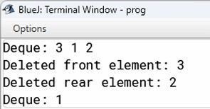
Output:

Q30) Write a program to implement CircularQ with insert(), delete() and print() methods.
Algorithm:
STEP 1: START
STEP 2: Initialize a circular queue with a specified size STEP 3: Define a function to insert an element into the queue
STEP 4: Define a function to delete an element from the queue
STEP 5: Define a function to print all elements in the queue
STEP 6: Define a function to check if the queue is full
STEP 7: Define a function to check if the queue is empty
STEP 8: In the `main` method:
STEP 9: STOP
Source Code:
public class CircularQueue { int[] queue;
int size;
int front, rear, count;

// Constructor to initialize the queue public CircularQueue(int n) {
size = n;
queue = new int[size]; front = 0;
rear = -1;
count = 0;
}

// Method to insert an element into the queue public void insert(int n) {
if (isFull()) {
System.out.println("Queue is full. Cannot insert " + n);
} else {
rear = (rear + 1) % size; // Circular increment queue[rear] = n;
count++; System.out.println("Inserted " + n);
}
}

// Method to delete an element from the queue public void delete() {
if (isEmpty()) {
System.out.println("Queue is empty. Cannot delete.");
} else {
System.out.println("Deleted " + queue[front]); front = (front + 1) % size; // Circular increment count--;
}
}

// Method to print all elements in the queue public void print() {
if (isEmpty()) { System.out.println("Queue is empty.");
} else {
System.out.print("Queue elements: "); int i = front;
for (int j = 0; j < count; j++) { System.out.print(queue[i] + " ");
i = (i + 1) % size; // Circular increment

}
System.out.println();
}
}

// Check if the queue is full private boolean isFull() {
return count == size;
}

// Check if the queue is empty private boolean isEmpty() {
return count == 0;
}

// Main method to test the CircularQueue public static void main(String[] args) {
CircularQueue cq = new CircularQueue(5); // Creating a circular queue of size 5

cq.insert(10); cq.insert(20); cq.insert(30); cq.insert(40); cq.insert(50);
cq.print(); // Output: Queue elements: 10 20 30 40 50 cq.delete();
cq.delete();
cq.print(); // Output: Queue elements: 30 40 50 cq.insert(60);
cq.insert(70);

cq.print(); // Output: Queue elements: 30 40 50 60 70
}
}

VDT:

Variable | Datatype | Function
Q | int[] | Stores the integers in array
size | int | Stores the length of array
front | int | Stores integral value
rear | int | Stores integral value
count | int | Stores integral value
n | int | Stores integral value
x | int | Stores integral value
j | int | Stores integral value

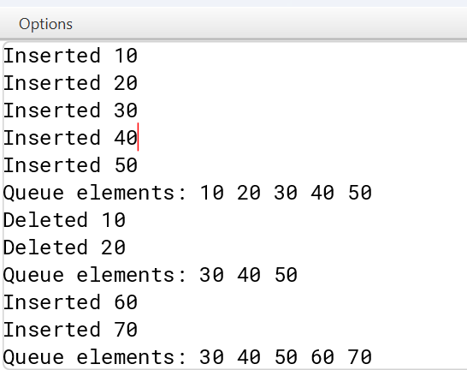
Output:

